Montana’s Earthquake History

Montana is one of the most seismically active States in the Union. Since 1925, the State has experienced five shocks that reached intensity VIII or greater (Modified Mercalli Scale). During the same interval hundreds of less severe tremors were felt within the State. Montana's earthquake activity is concentrated mostly in the mountainous western third of the state, which lies within a seismic zone that also includes southeastern Idaho, western Wyoming, and central Utah.

While there have been 4,680 earthquakes in Montana since 1931, there have been few deaths, as most earthquakes happen in mountainous regions and the population in the quake areas is fairly low.

On June 27th, 1925, at 6:21pm, Montana experienced a significant earthquake with a magnitude 6. The quake occurred a short distance southeast of Lombard. Due to the hour at which it occurred and to other fortunate circumstances, no lives were lost and no fires broke out. The shock extended 75 miles or more in all directions from the epicenter and was felt within an area of 310,000 square miles. The greatest damage caused by the earthquake was shown by the school buildings at Manhattan, Logan, and Three Forks, all of which were unreinforced brick construction. At Deer Park a large rockslide blocked the Chicago, Milwaukee & St. Paul Railway.

MONTANA EARTHQUAKE INFORMATION
Yearly Average Number of Earthquakes in Montana | 56
Total Number of Earthquakes in Montana since 1931 | 4680
Counties with the Highest Risk of Earthquakes | Gallatin, Madison, and Broadwater County
Total Number of Earthquakes in Carbon County since 1931 | 0

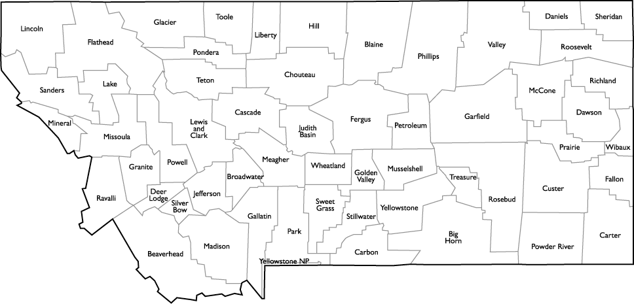

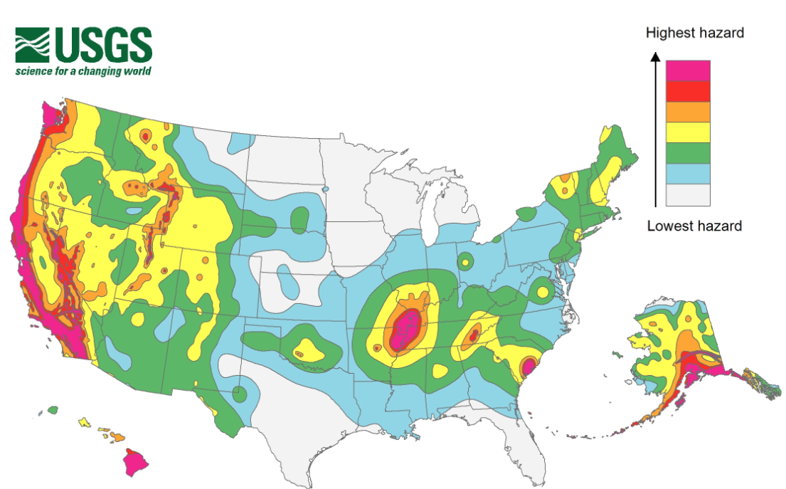

Largest Earthquake in Montana’s History

Location: Hebgen Lake, Montana
Date: August 17th, 1959
Richter Magnitude 7.3
Modified Mercalli Intensity X

Hebgen Lake is a man-made lake, retained by an earth-fill dam. It was and is a popular vacation and fishing spot, near Yellowstone National Park. In 1959 an earthquake with a magnitude of 7.5 occurred along a fault that crosses the Madison River.
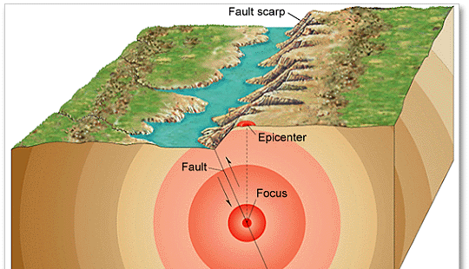
The 1959 Hebgen Lake earthquake, also known as the 1959 Yellowstone earthquake occurred on August 17 at 11:37 pm (MST) in southwestern Montana. The earthquake measured 7.3 – 7.5 on the Richter magnitude scale. Effects of the earthquake were also felt in Idaho and Wyoming.

This earthquake caused 28 fatalities and about $11 million in damage to highways and timber. It is characterized by extensive fault scarps (feature on the surface of the earth that looks like a step caused by slip on the fault), subsidence (caving in or sinking of land) and uplift, a massive landslide, and a seiche (disturbance in the water level) in Hebgen Lake. A maximum Modified Mercalli Intensity X was assigned to the fault scarps in the epicentral area.
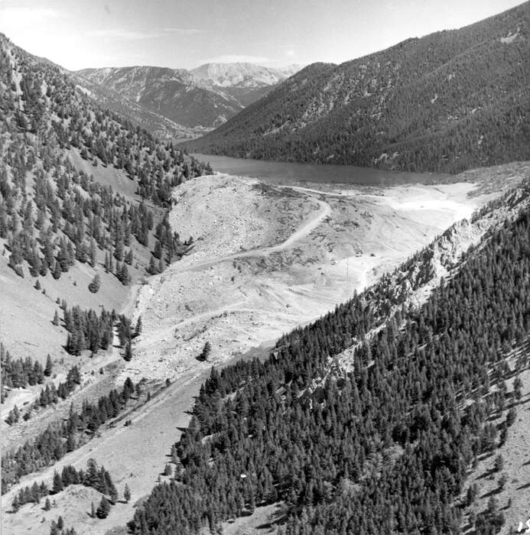

The most spectacular and disastrous effect of the earthquake was the huge avalanche of rock, soil and trees that cascaded from the steep south wall of the Madison River Canyon. This slide formed a barrier that blocked the gorge and stopped the flow of the Madison River and, within a few weeks, created a lake almost 53 meters deep (now called Quake Lake or Earthquake Lake). The volume of material that blocked the Madison River below Hebgen Dam has been estimated at 28 - 33 million cubic meters. Twenty-six deaths were caused by rockslides that covered the Rock Creek public campground on the Madison River, about 9.5 kilometers below Hebgen Dam. Two other campers were killed by rolling boulders at Cliff Lake.

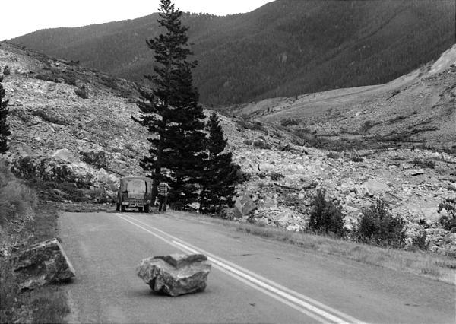

New fault scarps as high as 6 meters formed near Hebgen Lake. The major fault scarps formed along pre-existing normal faults northeast of Hebgen Lake. As a result of the faulting near Hebgen Lake, the bedrock beneath the lake was permanently warped, causing the lake floor to drop and generate a seiche that lasted for 11.5 hours and produced 1meter high waves. The dam sustained 16 significant cracks in its concrete core and spillway, and water overflowed Hebgen Dam.

After the quake, the surface of Hebgen Lake dropped 3 meters. Two kilometers of the river and Montana highway 287 were buried to depths as great as 394 feet. In four places, sections of Highway 287 broke away and slid into Hebgen Lake. After the magnitude 7.1 earthquake, the fault scarp near Hebgen Lake showed a vertical displacement of 7 meters.

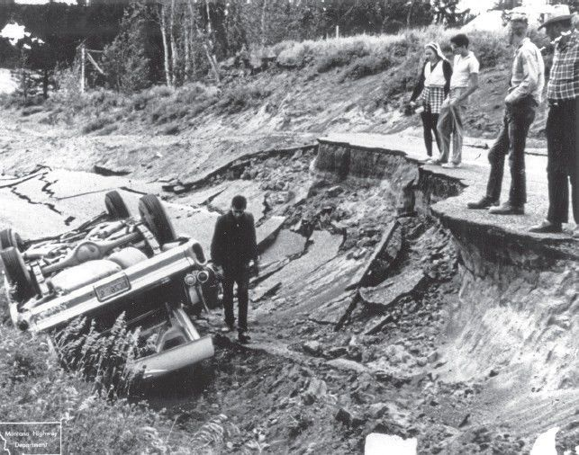

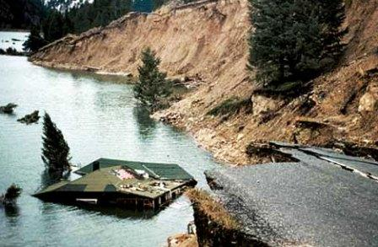
Many summer houses in the Hebgen Lake area were damaged: houses and cabins shifted off their foundations, chimneys fell, and pipelines broke. Roadways were cracked and shifted extensively, and much timber was destroyed. Highway damage near Hebgen Lake was due to landslides slumping vertically and flowing laterally beneath pavements and bridges, which caused severe cracks and destruction. Three of the five reinforced bridges in the epicentral area also sustained significant damage.

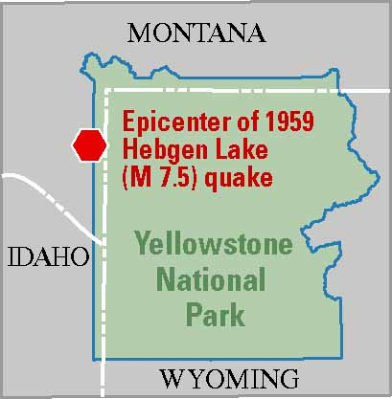
In the northwest section of Yellowstone National Park, new geysers erupted and massive slumping caused large cracks in the ground from which steam emitted. Many hot springs became muddy.

Minor damage occurred throughout southern Montana, northeast Idaho, and northwest Wyoming. Felt as far as Seattle, Washington, to the west; Banff, Canada, to the north; Dickinson, North Dakota, to the east; and Provo, Utah, to the south. This area includes nine Western States and three Canadian Provinces. Aftershocks continued for several months.

The Forest service established the Madison River Canyon Earthquake area to preserve the earthquake features. A visitor center with a seismograph is maintained by the Forest Service. Memorial markers were placed at the location in memory of those who perished in the quake.

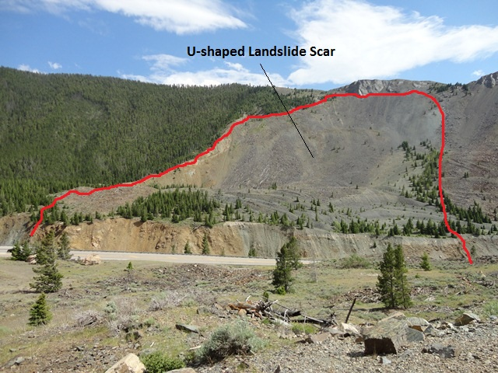

EARTHQUAKE MYTH OR FACT?
1. “Animals can predict earthquakes.” | ???- The earliest reference we have to unusual animal behavior prior to a significant earthquake is from Greece in 373 BC. Rats, weasels, snakes, and centipedes reportedly left their homes and headed for safety several days before a destructive earthquake. However, there is no consistent and reliable behavior prior to seismic events. Scientists are still pursuing this mystery in China and Japan.
2. “California will fall into the sea because of an earthquake.” | MYTH- The strike-slip earthquakes on the San Andreas Fault are a result of the Pacific and North American plate motion. The plates are moving horizontally past one another, so California is not going to fall into the ocean. However, Los Angeles and San Francisco will one day be adjacent to one another!
3. “Naturally occurring earthquake activity has been increasing. This means a big one is going to hit.” | MYTH- A temporary increase or decrease in seismic activity is part of the normal fluctuation of earthquake rates. Neither an increase or decrease worldwide is a positive indication that a large earthquake is imminent.
4. “MegaQuakes with a magnitude of 10 or larger can happen.” | MYTH- The magnitude of an earthquake is related to the length of the fault on which it occurs. The longer the fault, the larger the earthquake. No fault long enough to generate a magnitude 10 earthquake is known to exist. The largest earthquake ever recorded was a magnitude 9.6 on May 22, 1960 in Chile on a fault that is almost 1,000 miles long.
“The ground opens up during an earthquake.” | MYTH- Shallow crevasses can form during earthquake-induced landslides, lateral spreads, or ground failures. Faults, however, do not open up during an earthquake. If faults opened up, no earthquake would occur because there would be no friction to lock them together.

